**演示模式使用说明**

**Instruction of demo mode**

## 准备工作 Preparation

* 如果当前手机使用过，则**先还原手机，**避免切换失败。

路径：设置-其他设置-备份与重置-恢复出厂设置-抹掉全部内容与设置。

* 将当前手机连接网络，确保网络通畅。
* 确保当前手机电量不低于 60%。
* 切换过程中不要触碰手机的按键，不要重启，以免切换失败。
* If the current mobile phone has been used, restore the mobile phone first to avoid the switching failure.

Path: Settings - Other Settings - Backup & Reset - Restore Factory Settings - erase all content and settings.

* Connect the current mobile phone to the network to ensure smooth network.
* Ensure that the current mobile phone power is not less than 60%.
* Do not touch the button of the mobile phone during the switching process, do not restart, so as to avoid the switching failure.

## 切换流程 Switching Process

1. 打开浏览器，开启扫码，扫描以下二维码，弹框提示下载“演示模式引导器”，下载后安装，如无扫码软件，则输入对应网址。

Open the browser, open the scan code mode, scan the following QR code, and it shows to download the "Demo Mode Bootloader.apk". After downloading, install it.

二维码QR code：



1. 安装完毕后打开演示模式引导器，下载安装演示模式应用，下载成功后手机将会进行重启。

After the installation is complete, open the demo mode bootloader, then download and install demo mode APP, the phone will be restarted after successful installation.

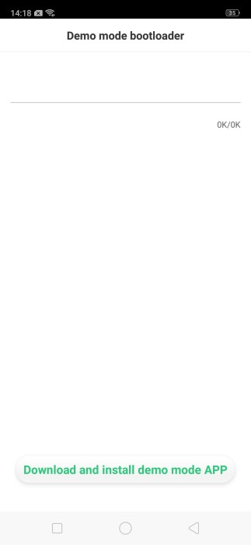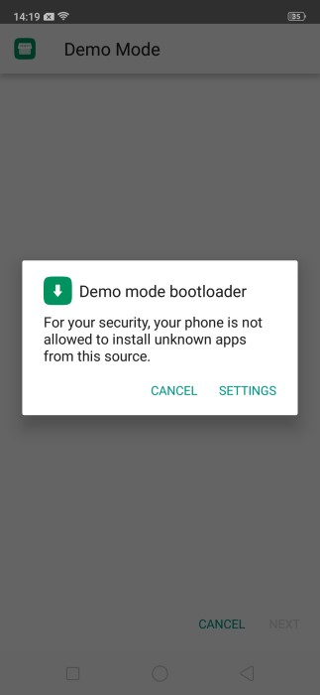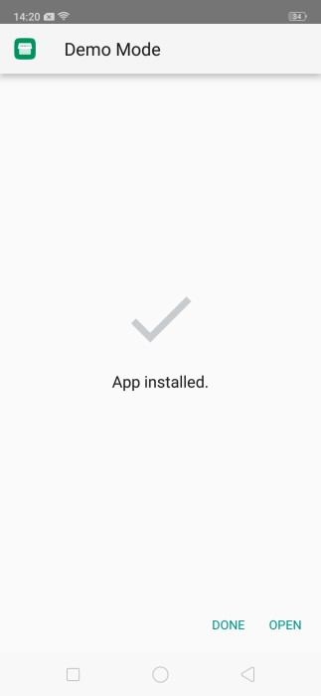

1. 打开演示模式后，点击“将手机切换为演示模式”按钮，弹框点击“仍旧切换”,保持该页面在前台，保持网络通畅，下载完毕后手机会自动重启。

After opening the demo mode, click the “Connect the network to switch to demo mode” button, then click “still switching” in the dialog box, keep the page in the foreground and keep the network smooth, and the phone will automatically be restarted.

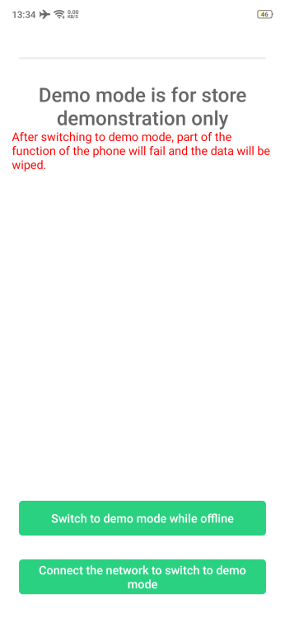 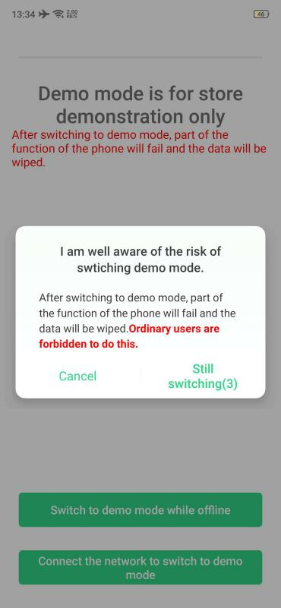

1. 手机重启后，会弹出对话框，点击“切换”以及“切换和重启”，手机将重启并自动切换到演示模式。此时查看状态栏有“演示样机”字样，再次运行演示模式应用，提示“手机当前已经处于演示模式”。

After restarting, the dialog box”According to company regulations, the demo prototype should ensure that it is switched to the full Sale mode” will pop up. Then, click “Go to switch”, and click “Activate and Reboot”. The mobile phone will be restarted, then, it has been switched to the demo mode. At this time, the status bar has the word “demo phone”, and run the demo mode APP again, prompting “the phone is already in demo mode”.

